

Faculty of Applied Science and Technology

Lab #6 – Branches and Loops in Matlab
Michaël McCorkell
Dr. Maryam Davoudpour
November 12, 2025
Procedures and results:
1.
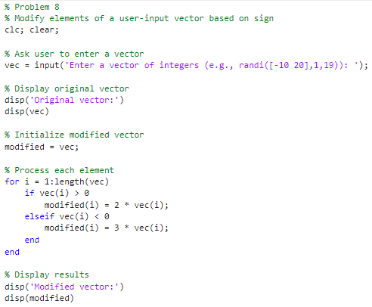

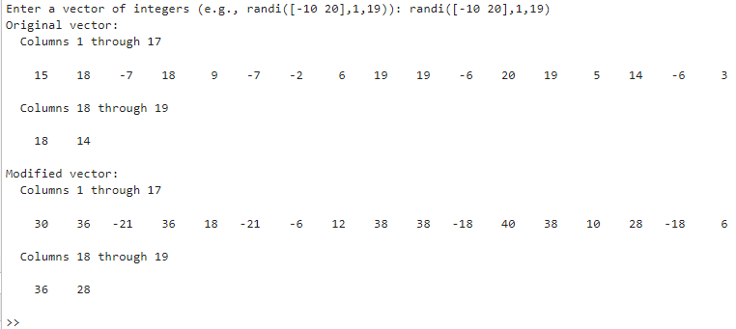

2.
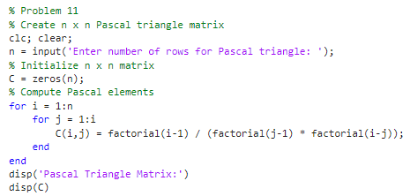

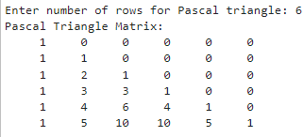

3.
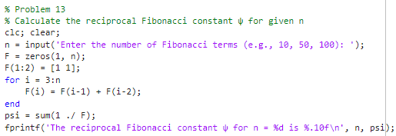

4.
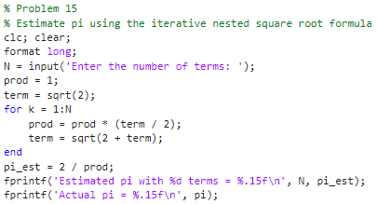
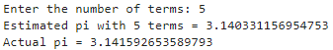
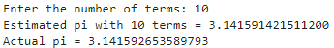
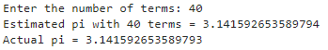

5.
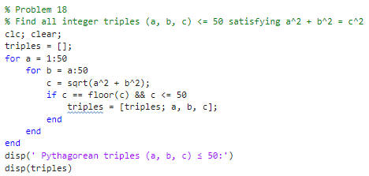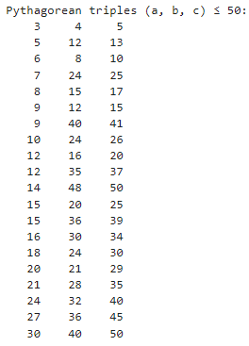
6.
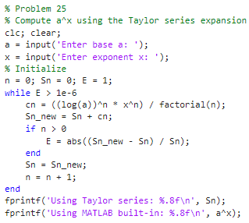
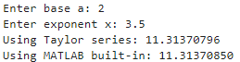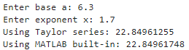

7. Tracing Exercise
n = [1 -88 300 27 -10 17];
p = n(1);
for j = 3:length(n),
p = p + n(j)
end

Output:
300+1 -> P = 301
301+27 -> P = 328
328-10 -> P = 318
318+17 -> P = 335

k = 0;
tt = 10;
while k < 15
k = k + 3
tt = tt + k
end
disp (k)
disp (tt)

Output:
1st Loop  0+3 -> K = 3  10+3 -> tt = 13 | 2nd Loop  3+3 -> K = 6  13+6 -> tt = 19 | 3rd Loop  6+3 -> K = 9  19+9 -> tt = 28 | 4th Loop  9+3 -> K = 12  28+12 -> tt = 40 | 5th loop  12+3 -> K = 15  40+15->tt = 55
15
55

References:
Gilat, A. (2017). MATLAB: An introduction with applications (6th ed.). John Wiley & Sons.

